CompanyName

Data Center / Server

Business Case
Prepared for: CompanyName
Date Prepared: Tuesday, June 12, 2018

This document contains sample dynamic content from the “IT Project ROI and Business Case Toolkit”. It is designed to be used with the “AnalysisPlace Excel-to-Word Document Automation Add-In” to automatically update the dynamic/linked content. You may modify it for your own use.
Executive Summary
The table and charts below summarize key results, including project costs, benefits, ROI, NPV, IRR, and payback period. The results are shown "per user" average and the total for the organization.

Financial Analysis Summary
 | Per User | Organization Total (000)
Costs | $149 | $411
Benefits | $1,057 | $2,909
Net Benefits | $908 | $2,498
NPV (Net Present Value) | $703 | $1,934
ROI | 608%
IRR (Internal Rate of Return) | 216%
Payback Period (Months)** | 5
Number of Users | 2752
*Return on Investment - [Net Benefits / Total Costs]
**From when benefits start to accrue

The tool also estimates current and projected KPI performance levels before and after the solution is implemented. This is summarized in the chart below:

Current Environment
The tables below show the organization profile data that was entered into the tool and used to estimate the solution costs and benefits.

Organization Profile
Below is key information about the organization.
Organization Name | CompanyName
Industry | Average or combination
Location | NORTH AMERICA - United States
Employees / FTEs (in project scope) | 5000
Organization Revenue (Millions) in scope | $2,234
Number of PC Users (in scope) | 2752
Total Number of PCs (in scope) | 3275

Solution Selected for this Analysis
The table below summarizes the extent of the organization's adoption of BI capabilities. The simulated (to-be) adoption is based on the scope/scale of selected initiatives enabling increased capability adoption. All costs in this model are based on scope/scale of initiatives selected. All benefits in this model are based on improvements to capability adoption - adoption of more BI capabilities and best practices lead to improved business performance. Details are contained in the "Initiatives" worksheet.
Project Name: | Data Center / Server
Project Description: | • Virtualization, consolidation, clustering, real-time infrastructure, self-service provisioning, power and cooling  • Improved performance, reliability, manageability, security  • Multi-core, 64-bit, RISC/Itanium, x86  • Web servers, application servers, DBMS servers, data warehouse servers, infrastructure servers, high performance computing servers
Project Scale (Investment level) | Minor (e.g. enhancement/upgrade)

Overview of the IT Project ROI and Business Case Toolkit
The IT Project ROI and Business Case Toolkit enables rapid development of comprehensive business cases for IT projects. It helps organizations to assess, quantify, and communicate the costs, benefits, business value, and ROI of most types of enterprise-scale technology-based initiatives. It also helps to assess the organization’s current (as-is) and expected (to-be) IT spending (TCO) levels and the solution’s impact on a variety of key performance indicators (KPIs). It produces editable business case reports that can be presented to decision-makers.
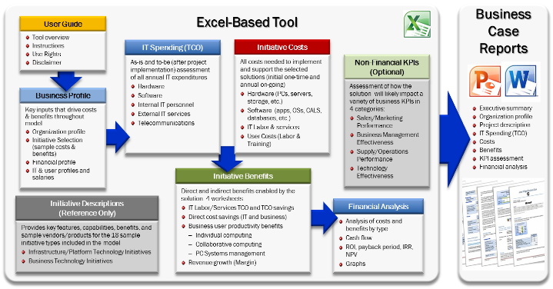
Figure 1 IT Project ROI and Business Case Toolkit Components Diagram
The model simulates "To-Be" capability adoption based on initiatives selected by the model user. The model estimates
The tool estimates the costs required to implement the new capabilities/solution, including hardware, software, IT labor, services, and user labor. It simulates benefits (user productivity, IT TCO savings, business cost savings, revenue growth, and KPI improvements) enabled by the solutions selected.
It supports both rapid (30 minute) and highly detailed assessments. The tool uses industry best-practice methods and research to assist the organization in assessing the costs and benefits of investing in the IT initiative. However, this tool cannot accurately/credibly estimate costs/benefits without review, validation, and adjustment of key data inputs. These inputs should be customized to each particular organization and scenario.

