AnalysisPlace’s

Excel-to-Word

Document Automation

for MyCustomer
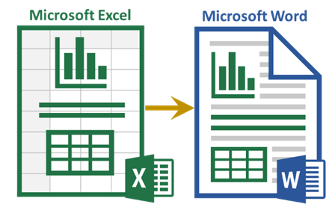

Automatically update Word content (text, tables, and charts) based on Excel data and analysis
This document demonstrates how the AnalysisPlace “Excel-to-Word Document Automation” Add-in works and contains instructions on how to use the add-in to update and link content. The “dynamic” content will be updated based on the data submitted from Excel when you click “Update Document” in the Update tab. The text below is updated based on the Excel “rpt_TextSummary” range under the “Summary” heading:
MyCustomer can realize $1,828,838 in benefits with an investment of only $689,989 -- that is an ROI of 165%.
The table below is updated based on the “rpt_ROISumTable” range in Excel:
 | One Time | Annual | Total
Costs | $383,255 | $61,347 | $689,989
Benefits | $0 | $365,768 | $1,828,838
Net Benefits |  |  | $1,138,849
The chart below is updated based on the Excel chart named “rpt_CostsVsBenefitsChart”:
The Excel-to-Word Document Automation Add-in automates updating of Excel-based content into Word and PowerPoint documents. Updatable content includes text, tables, lists, and charts. It also makes it easy to link the “dynamic” content to be updated. | 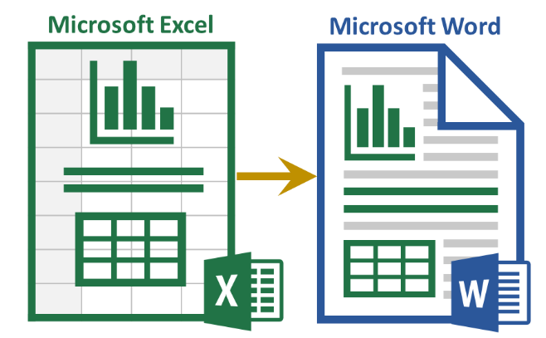

Basic Instructions to Update Content from Excel
- Install and activate the add-in in both Excel and Word (see appendix for how)
- In Excel, modify one or more of the tan input cells.
- In Excel, on the “Submit” tab of the add-in, click “Submit Content”.
- In Word, click “Update Document” on the “Update” tab. This should update the “linked” items in the Content Controls below
View additional details here: https://analysisplace.com/Solutions/Document-Automation
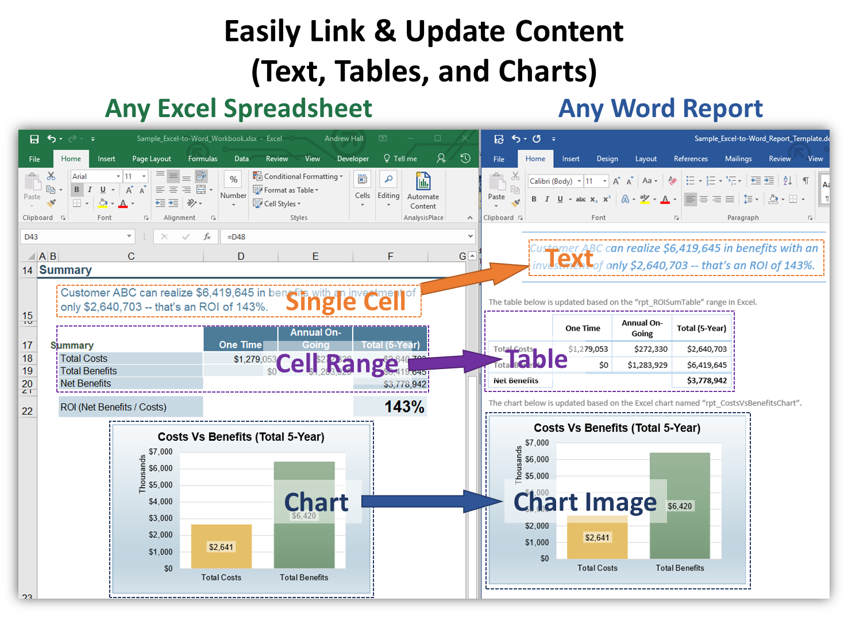
There are a variety of other ways that the add-in can submit information from Excel to Word. The table below is based on ”rpt_ExpensesTable_visible”. It will be resized to match the visible rows/columns of the source table in Excel.
Merchant | Date | Category | Amount
The Phone Company | 11/1/2018 | Communications | $120
Northwind Electric Cars | 11/2/2018 | Transportation | $142
Best For You Organics Company | 11/5/2018 | Groceries | $27
Coho Vineyard | 11/10/2018 | Restaurant | $33
Best For You Organics Company | 11/15/2018 | Groceries | $97

The dynamic list below is updated based on the “rpt_ScopeList” range (single-cell) in Excel:
- Basic Features
- Advanced Features
- Management Module
- Support Services (5 Years)

How to “Link” Dynamic Content
In Word, content that can be updated from Excel is said to be “dynamic” content. This dynamic content must be “linked” to its source in Excel.
In Excel, the source (chart and ranges) of the dynamic content must be named: see the next section for how to name them.
In Word, all dynamic content must be in Content Controls. The add-in shows you what source content is available and allows you to create the Content Control links on the “Link” tab.

The 3 Item Content Types
All dynamic content must be in Content Controls. 3 types of content can be transferred from Excel to Word:

Text Items (based on a single cell range in Excel)
- Can appear anywhere in the Word doc.
- Only the text in the Content Control is updated from Excel, not the style/format. It will match the style of the surrounding text in Word.
- In Excel, select a single cell range, then enter the name (with the “Item Name Prefix”) in the Name box (to the left of the formula bar).
- In Word, select where you’d like to text to appear. On the add-in “Link Content to Excel” section, select the appropriate item from the drop-down, then click “Create/Update Link”
- The add-in also supports inserting HTML content (see Advanced Features)

Tables (based on a range in Excel)
- In Excel, name the range (with the “Item Name Prefix”)
- In Word, create/copy a Word table with the same dimensions (rows and columns), select the table, select the appropriate drop-downs, then click the “Create/Update Link”. Alternatively, if you don’t have an existing table selected, the add-in will create it – you can then style it.
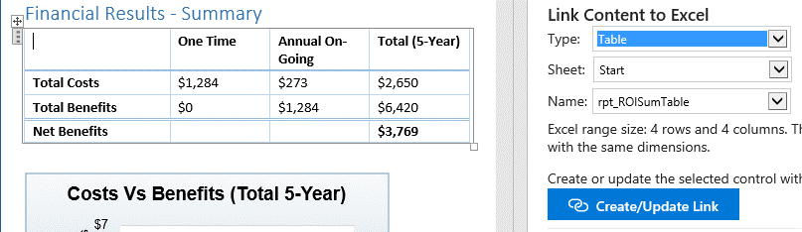
- Styles/formats
  - The add-in only modifies the text in the table cells, so you can format (borders, colors, fonts) the table any way you want and the formatting will not change.
- Rows/Columns
  - The Word Add-in can insert/delete rows/columns to match the number of rows in Excel.
  - Dynamic ranges (where range size changes based on a variable) are not supported
- Merged Cells
  - You can have merged cells in Excel ranges and their corresponding Word tables. However, to ensure the Word add-in places the text in the correct cells, do the following in Excel for all table rows that contain merged cells:
    - 1) ensure that the hidden cells of the merged area are empty. You can do this simply by unmerging (deletes the hidden content), then re-merging.
    - 2) any cell that is blank and you want to remain visible in Word, enter a SPACE character in Excel so Word knows it is not part of the merged hidden area
- Performance
  - A document with dozens of large tables can take time to update (over a minute).

Charts (are based on charts in Excel)
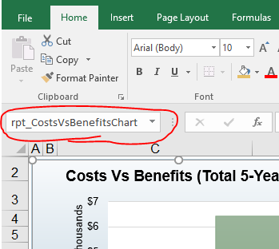
- The chart must be named with your “Item Name Prefix”. To name a chart: select the chart, then enter a name in the name box.
- Charts appear as png images in Word and cannot be edited in Word
- You can make any type of chart and style any way in Excel
- Image size in Word matches its size in Excel.
- Currently, the add-in does not support updating native charts in Word (this is only supported in PowerPoint)

Common Usage Scenarios
This add-in can be used in a wide variety of document automation scenarios. Here are a few:
- Customer business cases (from an Excel-based ROI/TCO Tool)
- Personalized sales and marketing collateral, including proposals and quotes
- Custom product documentation (from Excel sizing/capacity/configurator)
- Recurring financial reports (from Excel analysis)
- Custom datasheets (from engineering/scientific calculations in Excel)

Advanced Features
The add-in supports a variety of other features. For example Currency Switching, Multi-lingual Reports, Advanced Graphs, Automatic Table Resizing, Inserting HTML, Document Assembly, Conditional Submit, Table Merged Cells, Dynamic Lists, and Paragraphs, Professional Word layouts, Mail Merge, etc.
Please see: https://analysisplace.com/Resources/Templates#Advanced Features

Enterprise Features
The add-in also supports capabilities that enable you to create, deploy, manage, and monitor Excel-based tools that are used by multiple users (including template-based report generation). Please see details here: https://analysisplace.com/Document-Automation/Enterprise

Requirements
This add-in requires Office 2016 (Office 365 subscription version) or newer and an internet connection.
- Office 365 for Windows (subscription version): requires version 1705 (Build 8121.1000) or later.
- Office 2016 for Windows (non-subscription): requires version 16.0.4678.1000 or later. Most Office 2016 installed versions are not compatible.
- Office for Mac: requires version 15.34 or later (Office 365 subscription version).
- Office 2019: all Windows and Mac versions are compatible.
- Office Online, via OneDrive or SharePoint: compatible, but with some limitations.

Support
Please contact AnalysisPlace for any questions, issues, or suggestions.
https://analysisplace.com/Contact-Us

About AnalysisPlace
AnalysisPlace builds the Excel-to-Word Documentation Add-in and custom ROI-based selling tools. Our Add-in helps corporations and entrepreneurs work smarter and faster by automating the updating of Word or PowerPoint from Excel.

Appendix - Add-In Installation Instuctions
- In both Excel and Word 2016, select the "Insert" tab on the ribbon. In the "Add-ins" section, select "Store"  - In the search box, enter "Document Automation", then select "Add"  - The add-in icon should appear in the ribbon on the "Home" tab on the right side. Select it to activate it. | 