Excel-to-Word Document Automation Add-In
Update/create Word and PowerPoint content (text, tables, and charts) based on Excel data and calculations.
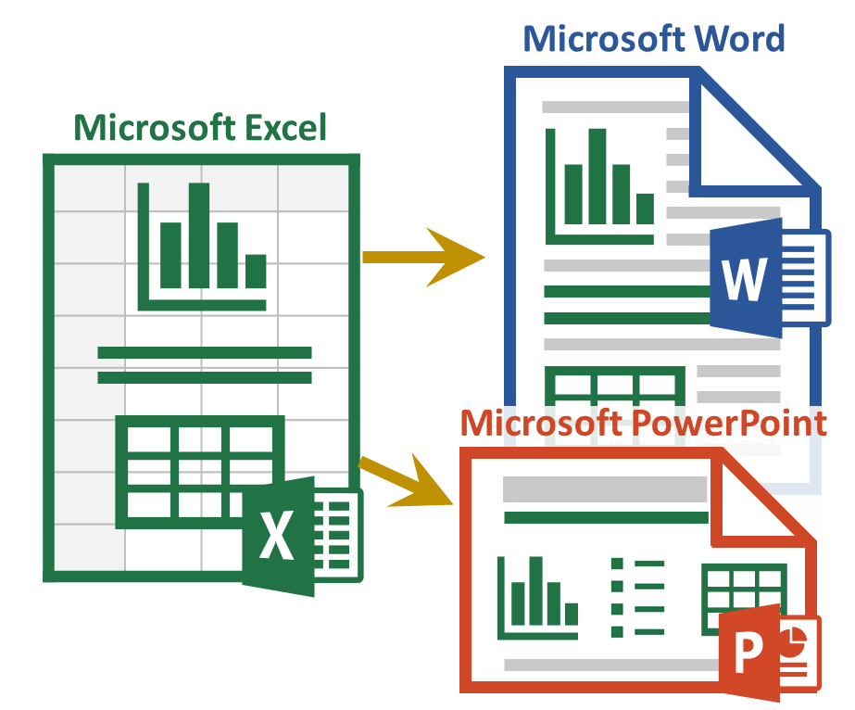

How-To Guide on Cloud Updating of Word Charts Based on Tables or Ranges in Excel

Introduction
This document along with the “AnalysisPlaceWordCharts.xlsx” workbook shows how the add-in can perform cloud updating of Word charts based on Tables or Ranges in Excel.
To use this document:
- Activate the add-in in the workbook “AnalysisPlaceWordCharts.xlsx” and this document.
- In Excel under the section “Examples to Update Word” change the number in the orange input cell. Updating the orange cell will change all of the charts.
- On the “Update” tab of the add-in in Excel choose “Submit Content”
- Switch to this Word document, choose "Cloud Update"(a) from the "Update" tab of the add-in. Once your document has been created you can download it by clicking on "Download Document" (b)
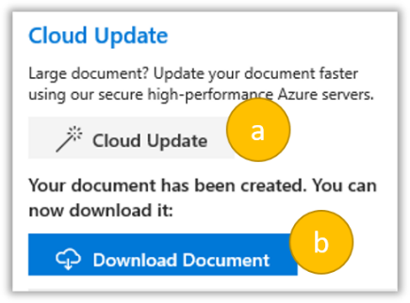
- You will be able to see the changes in the charts in Word, based on your Excel modifications in your downloaded document.
You are welcome to modify and use the content in these documents for your own use.
If you are not already familiar with the basic features of the add-in, first see: See https://analysisplace.com/Document-Automation/Get-Started
Examples to update in Word
The charts below have all been linked to tables from the Excel workbook “AnalysisPlaceCloudUpdateWordCharts.xlsx” using the tag {Table:Sheet1!r_CommonCharts_val} They will be updated when following the above directions. Test Value from Excel used to update tables 25

The Pie Charts below have been linked to the tables in Excel using the tag {Table:Sheet1!r_PieCharts_val}

The Scatter Charts below have been linked to the tables in Excel using the tags {Table:Sheet1!r_scatter_val} and {Table:Sheet1!r_Scatter2Series_val}

The Stock Chart below has been linked to the table in Excel using the tag {Table:Sheet1!r_StockChart_val}

